Friction - 03
CLASS 08 - SCIENCE

 | Section A
1 | What is avoided between two surfaces to make movement smooth? | [1]
2 | What are fluids? | [1]
3 | Name some objects which have streamlined body. | [1]
4 | What happens, if the floor we walk on is frictionless? | [1]
5 | What is the function of ridges on your palm and bottom of your feet? | [1]
6 | Does the use of ball bearing reduce or increase friction. | [1]
7 | What is fluid friction? | [1]
8 | Name the force responsible for wearing out of bicycle tyres. | [1]
9 | What is used to reduce friction in machines where lubrication are not advisable? | [1]
10 | Can we eliminate friction completely? | [1]
11 | Name any machine in which ball bearing is used to reduce friction. | [1]
12 | What does frictional force exerted on an object in a fluid depend on? | [1]
13 | Explain why sportsman use shoes with spikes. | [1]
14 | Why do pieces of luggage fitted with rollers? | [1]
15 | When does rolling friction come into play? | [1]
16 | Name the special shape given to objects moving in fluid. | [1]
17 | What is the cause of friction? | [1]
18 | How sliding friction is replaced by rolling in machines? | [1]
19 | Name the substance which is used in carrom board to reduce friction. | [1]
20 | What is used in cycle brakes to increase friction? | [1]
21 | On which kind of surface the friction will be greater(i) smooth surface. (ii) rough surface. | [1]
22 | What is drag? | [1]
23 | What do we usein cycle brakes to increase friction? | [1]
24 | Enlist any four methods of reducing friction. | [2]
25 | Suppose your writing desk is tilted a little. A book kept on it starts sliding down. Show the direction of frictional force acting on it. | [2]
26 | Describe some examples where heat is produced due to friction. | [2]
27 | Fig. shows two boys applying force on a box. If the magnitude of the force applied by each is equal, will the box experience any force of friction? 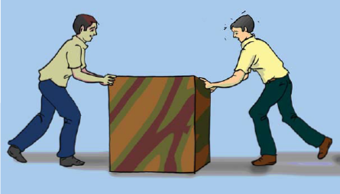 | [2]
28 | Amitis pushing a heavy trunk on the floor. Finding it a little difficult, he turns the trunk to place it vertically. Will he need to do less effort now? Explain. | [2]
29 | Will the force of friction come into play when a raindrop rolls down a glass window plane? | [2]
30 | Two blocks of iron of different masses are kept on a cemented floor as shown in Fig. Which one of them would require a larger force to move it from the rest position? 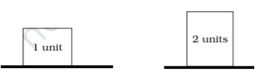 | [2]
31 | Describe some events when we have reduce the friction. | [2]
32 | Name two factors on which the magnitude of the frictional force depends? | [2]
33 | Name the two factors on which the magnitude of the frictional force depends. | [2]
34 | Explain why objects moving in fluids must have special shapes. | [2]
35 | You might have noticed that when used for a long time, slippers with rubber soles become slippery. Explain the reason. | [2]
36 | You spill a bucket of soapy water on a marble floor accidently. Would it make it easier or more difficult for you to walk on the floor? Why? | [2]
37 | Describe some examples where we deliberately increase friction. | [2]
38 | What is a spring balance? | [2]
39 | List the name of five smooth surfaces and five rough surfaces from your surroundings. | [2]
40 | Why do we shape aeroplanes like that of a bird? | [2]
41 | Explain why it is convenient to pull the luggages fitted with rollers. | [2]
42 | You would not have forgotten the accident that happened to astronaut Kalpana Chawla. What was the reason behind that? | [2]
43 | Iqbal has to push a lighter box and Seema has to push a similar heavier box on the same floor. Who will have to apply a larger force and why? | [2]
44 | Describe some events where friction is harmful to us. | [2]
45 | On what factors does the fluid friction depend on? | [2]
46 | Why objects given special shape which is moving in fluids? | [2]
47 | Why the soles of our shoes and tyres of cars, trucks etc are grooved? | [2]
48 | Explain why we use ball bearings between the hub and axle of ceiling fan and bicycle. | [2]
49 | A marble is allowed to roll down an inclined plane from a fixed height. At the foot of the inclined plane, it moves on a horizontal surface  - covered with silk cloth  - covered with a layer of sand and  - covered with a glass sheet.  On which surface will the marble move the shortest distance. Give a reason for your answer. | [2]
50 | Explain why sliding friction is less than static friction. | [2]
51 | On what factors does the fluid friction depends? | [2]
52 | How the fluid friction can be minimized? | [2]
53 | While playing tug of war, Preeti felt that the rope was slipping through her hands. Suggest a way out for her to prevent this. 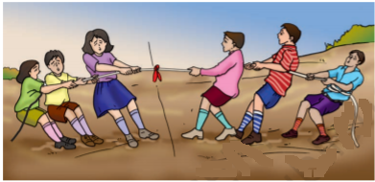 | [3]
54 | What are the factors on which frictional force depends in fluids? | [3]
55 | What is static and sliding friction? | [3]
56 | Give examples to show that friction is both a friend and a foe. | [3]
57 | Is there a force of friction between the wheels of a moving train and iron rails? If yes, name the type of friction. If an air cushion can be introduced between the wheel and the rail, what effect will it have on the friction? | [3]
58 | Describe some events where friction is harmful to us? | [3]
59 | Explain why the surface of mortar and pestle (silbatta) used for grinding is etched again after prolonged use? | [3]
60 | The handle of a cricket bat or a badminton racquet is usually rough. Explain the reason. | [3]
61 | We have two identical metal sheets. One of them is rubbed with sandpaper and the other with ordinary paper. The one rubbed with sandpaper shines more than the other. Give reason. | [3]
62 | Why can’t we write with a chalk if there were no friction? | [3]
63 | Explain in details why friction is called necessary evil. | [3]
64 | While travelling on a rickshaw, you might have experienced that if the seat cover is very smooth, you tend to slip when brakes are applied suddenly. Explain. | [3]
65 | The soles of our shoes get worn out after a period of time. Explain why? | [3]
66 | State advantages and disadvantages of fluid friction? | [4]
67 | The tyres of automobiles are made corrugated and rough. Why? | [4]
68 | Explain why rolling friction less than sliding friction? | [4]
69 | - When you play a game of carom, what do you do to make the coins move smoothly on the board?  - If you try to hold a glass with soapy hands, it can easily slip from your hands. Why? | [4]
70 | Show with the help of activity that friction depends on the nature of two surfaces? | [4]
71 | Show with help of activity that weight of the object increase friction? | [4]
72 | Ram has to push a lighter box and Shikha has to push a similar heavier box on the floor. Who will have to apply larger force and why? | [4]
73 | Explain briefly any two methods of reducing friction? | [4]
74 | Describe some examples where we deliberately increase friction? | [4]
75 | Why do kabaddi players rub hands with soil? | [4]

